Group B

- What is an image map? Describe the key steps involved in creating a client image map in HTML using necessary tags and attributes.
- What is session? Explain how session works with proper example.
- What is CSS? Explain CSS Box model along with its related properties and example.
- What is tier Architecture? Differentiate two-tier technology with three-tier technology.
- What is web server? Explain different functions of web server.
- What is well formed XML? Explain different ways of DTD implementation for XML documents.
- Define XPath? Explain different elements required to create XSLT document.
- Create the following table using the HTML elements.
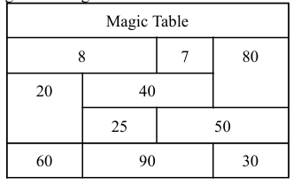

- What are the various font-related attributes in CSS? Explain with suitable example.
- How does Tier Technology function inside the architectural framework of a web application?
- How does a web server process and handle HTTP requests and responses with example?
- Create a server site script to use cookie variables for the login and logout process without using databases.
- Use server-site scripting to calculate the x using the data from two text boxes.
- What are the new form elements introduced in HTML5 and how do they differ from previous versions?
- Enlist and explain method of using CSS in web page.
- Write a form to collect details of a user such as name, address, radio button to choose subject of book he wants to buy, dropdown to choose favorite author.
- Explain Tier Technologies with example.
- How XSL is different from CSS? Explain.
- Define Session. Explain us use with example.
- Write an example of server side script to insert data in database.
- Explain the following with example:
<table> tag
Image map
- What is HTML5? Explain characteristics of HTML5.
- Write HTML tag to generate the following table.
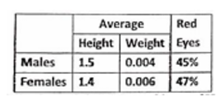

- Design the following website's Menu with use of HTML list and appropriate CSS.
Home | News | Contact |About
- Compare and contrast between a block-level element and an inline element in HTML?
- What is CSS Selector? Explain different types of selector with suitable example.
- Why session is required in web development? Explain how you set and remove values stored in Session with suitable example?
- Critically analysis the pitfall of the 3-tier technology in comparison with n-tier technology.
- What is CSS? Discuss types of CSS with example.
- What is XML? Differentiate XML schema with DTD.
- List common application of web server, Explain ,how session works.
- Describe the tags and attributes for a form in HTML document?
- What is anonymous access? Discuss about Integrated windows authentication.
- Explain tire technology with examples?
- Write short note on following:
• Cookies • XML DOM
- Difference Between Sessions and Cookies

Group C
- Design form to accept name, email, phone, gender, country and validate them using server script with following rules and store them into database called "store" and table "information". • All fields are required.
  - Phone number must contain 10 digit
  - Email must be valid format
- Write HTML and CSS code to design following layout.
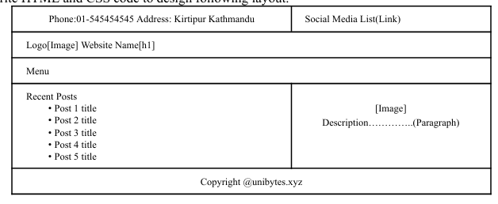

- Write a valid and well-formed xml to store details of visitor list of ABC College with following details and validate record with following information.
  - Record must include details of name, mobile, department, related contact person, date, entry time,exit time and visitor number as attribute.
  - Mobile must be 10 digit.
  - Visitor may not have any contact person .
  - Record must belongs to Admin, IT, Account and Exam Department.
- Given an XML document that contains a list of products with the following elements: productname, category, price, and quantity, write an XSLT stylesheet that:
    - Filters out any products that have a quantity less than 10
    - Groups the remaining products by category and creates a new XML document with a new element called "category" that contains the products within that category as child elements.
    - Within each category element, sorts the products by price in descending order.
    - Transforms the element "productname" into an attribute of each product element.
    - Add a new element called "total-price" to each product element, which contains the total price of the product (price quantity)

- Make a script for the server site to display the following data by reading from a database and saving any new values that the user has updated. Think about the specifications of your own database, if any.
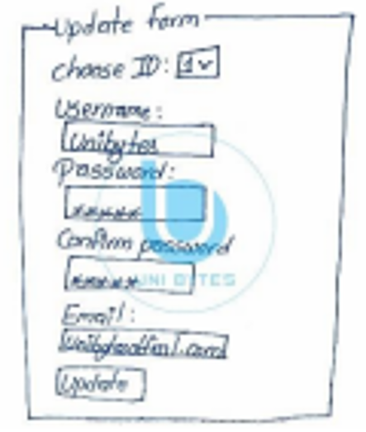

- Make a well-formed XML document as per the diagram below, then use an appropriate XSD document to validate it in consideration with below restrictions. XSD Restrictions:
    - The username must have a minimum of 8 characters.
    - The character limit for posts is 5 to 8.
    - The password must be 8 characters long and begin with Aa-Zz.
    - The gender must be one of male, female, or other.
    - The salary should range from Rs. 25,000 to Rs. 50,000.


- Write an HTML script with CSS for following elements with effects
      - Link: after visited red color and before visited blue color
      - Table with odd rows pink and even rows blue color.
      - Text color-green, Text-indentation-2cm, Text case-uppercase
- Explain the key component of XML file. Write an XML to describe "address" as an element and "state, city, municipality and house-no" as it's attributes. Also define XSD for the XML file.
- Write a server side script for implementing login. Your program should take username and password as input and redirect to home page if validated otherwise prints an error "try again".
- Design the following layout of webpage with use of div and appropriate CSS.

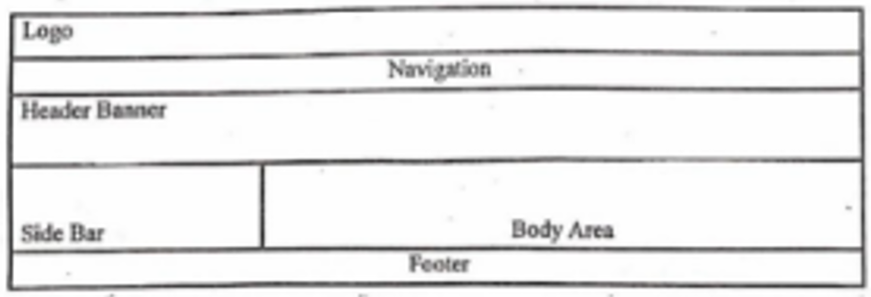

- Write a server-site script for login process assume that user name and password have already exist on database TU under the user table (id, user, password).
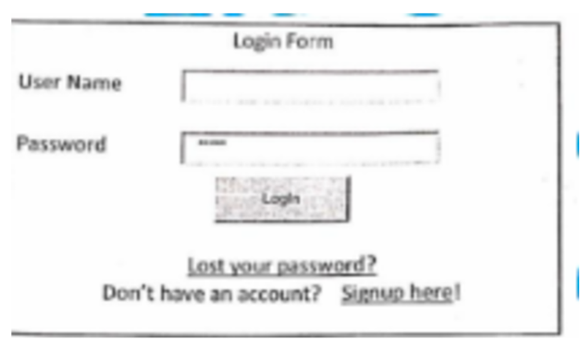

- What are the rules for Well-formed xml document? Create a sample well-formed xml and validate it with DTD Schema.
- Differentiate between tags and attributes? Write a HTML and CSS code design your curriculum vitae (CV) using different html elements like (table, image, formatting tags, links).
- Develop a simple web page that asks the users input (name, email, phone, gender) and store into database using server side script.
- What are the rules for creating XML document? Write a XML code to store following information about student.
  - Each student has a name, address, phone and website element.
  - Address might appears multiple times
  - Address has attribute named “type” with value permanent and temporary must be 10 digit.

